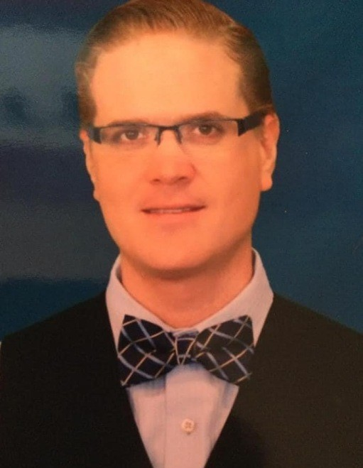
Mark Lawrence Rolands formerly of Lake Mills, Iowa, passed away at his home in Las Vegas, Nevada on April 2, 2021.
Although he was only 38, Mark affected many people in his lifetime. As a child growing up in a small town Mark knew and was friends with everyone. He had a big heart for helping others. Mark was very committed to serving our military men and women. He organized many events to honor those who served. Mark also was a living organ donor for his friend, Tony Tomkin.
Those who knew Mark lost a shining light in their lives. He was the entertainer of our family.
Mark will be missed everyday by his mother, Linda Rolands, his siblings, Jennifer Bausch (Jim Fuchsteiner), Michael (Melissa) Rolands, and Shawna Negrete. He will be missed by his nieces and nephews Madelyn, Justin, and Austin Bausch, Jonathan Rolands, and Kobe, Vada, Ava and Ella Negrete.
He was preceded in death by his father, Jon Rolands ( a Vietnam Veteran), and his grandparents Clayton (Adeline) Rolands, and Alfred (Beatrice) Stenstrude.
We will be having a private family celebration of Mark's life at a later date.

