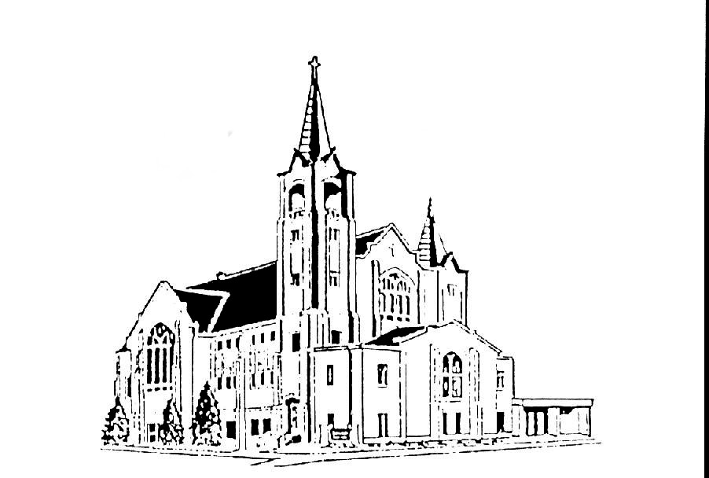 | Salem Lutheran Church  401 S. Lake St. Lake Mills IA 50450  Welcome to the House of the Lord  Transfiguration Of Our Lord  February 13, 2021 – 5:30pm

OUR MISSION: We are God forgiven and mission driven.

OUR VISION: To be that Lake Mills place where belonging, healing, growing, serving and believing are open to all, regardless of background, experience or aptitude. Central to this is that we are a forgiving, mission-driven community, which means we all want to have an impact, shaped by the love of Christ to serve all others.

Saturday--5:30pm Worship Service  Preaching: Pastor Joel Guttormson  Organist: Ruth Sheldon  Reader: Sondra Nelson  Liturgical Choir: open  Sound: Shannon Bruhns  Acolytes: Shannon Bruhns  Ushers: Shannon Bruhns  Communion Servers:  Alter Guild for Feb: Shelley Hagenson &  Sharon Johnson | Sunday--9:00am Worship Service  Preaching: Pastor Joel Guttormson  Organist: Ruth Sheldon  Reader: Margaret Oakland  Liturgical Choir: Bruce Adams, Al Skellenger, Willie Skellenger, Nancy Guttormson,  Sound: Chike Ikefuama  Live Stream: Brad Evenson  Video: Chike Ikefuama  Acolytes: open  Ushers: Lyle and Orloue Thomson  Communion Servers:  Altar Guild for Feb: Shelley Hagenson &  Sharon Johnson

The radio broadcast is given in loving memory of Jay Fjelstad from Roger & Dorothy Fjelstad and family.

Salem Contact Information:
Pastor Joel Guttormson: 641.596.0535  joelguttormson@gmail.com  Shannon Bruhns, Council President: 641.592.5978 / 641.590.1532  shelby@wctatel.net | Ruth Sheldon, Organist: 641.592.0184  Barb Kinseth, Custodian  Marci Adeogun, Office Admin: 641.590.1182  Salem Office: 641.592.1771  salem@wctatel.net

INTRODUCTION
The Sundays after Epiphany began with Jesus’ baptism and end with three disciples’ vision of his transfiguration. In Mark’s story of Jesus’ baptism, apparently only Jesus sees the Spirit descending and hears the words from heaven. But now Jesus’ three closest friends hear the same words naming him God’s Beloved. As believers, Paul writes, we are enabled to see the God-light in Jesus’ face, because the same God who created light in the first place has shone in our hearts to give us that vision. The light of God’s glory in Jesus has enlightened us through baptism and shines in us also for others to see.

GATHERING

PRELUDE

BELL

ANNOUNCEMENTS

CONFESSION AND FORGIVENESS

All may make the sign of the cross, the sign marked at baptism, as the presiding minister begins.

Blessed be the holy Trinity, ☩ one God, whose voice is upon the waters, whose mercy is poured out upon all people, whose goodness cascades over all creation.
Amen.

Let us confess our sin, trusting in the abundant grace of God.

Silence is kept for reflection.

Holy God,
you search us and know us. You are acquainted with all our ways. We confess that our hearts are burdened by sin—our own sins and the broken systems that bind us. We turn inward, failing to follow your outward way of love. We distrust those who are not like us. We exploit the earth and its resources and fail to consider generations to come. Forgive us, gracious God,
for all we have done and left undone. Even before the words are on our tongues, you know them; receive them in your divine mercy.
Amen.
How vast is God’s grace!
Through the power and promise of ☩ Christ Jesus, our sins are washed away and we are claimed as God’s own beloved. Indeed, we are forgiven. In the wake of God’s forgiveness, we are called to be the beloved community living out Christ’s justice and the Spirit’s reconciling peace.
Amen.

GATERING SONG Christ, Whose Glory Fills the Skies ELW #553

PRAYER OF THE DAY
Almighty God, the resplendent light of your truth shines from the mountaintop into our hearts. Transfigure us by your beloved Son, and illumine the world with your image, through Jesus Christ, our Savior and Lord, who lives and reigns with you and the Holy Spirit, one God, now and forever.
Amen

WORD

FIRST READING 2 Kings 2:1-12

¹Now when the Lord was about to take Elijah up to heaven by a whirlwind, Elijah and Elisha were on their way from Gilgal. ²Elijah said to Elisha, “Stay here; for the Lord has sent me as far as Bethel.” But Elisha said, “As the Lord lives, and as you yourself live, I will not leave you.” So they went down to Bethel. ³The company of prophets who were in Bethel came out to Elisha, and said to him, “Do you know that today the Lord will take your master away from you?” And he said, “Yes, I know; keep silent.”
⁴Elijah said to him, “Elisha, stay here; for the Lord has sent me to Jericho.” But he said, “As the Lord lives, and as you yourself live, I will not leave you.” So they came to Jericho. ⁵The company of prophets who were at Jericho drew near to Elisha, and said to him, “Do you know that today the Lord will take your master away from you?” And he answered, “Yes, I know; be silent.”
⁶Then Elijah said to him, “Stay here; for the Lord has sent me to the Jordan.” But he said, “As the Lord lives, and as you yourself live, I will not leave you.” So the two of them went on. ⁷Fifty men of the company of prophets also went, and stood at some distance from them, as they both were standing by the Jordan. ⁸Then Elijah took his mantle and rolled it up, and struck the water; the water was parted to the one side and to the other, until the two of them crossed on dry ground.
⁹When they had crossed, Elijah said to Elisha, “Tell me what I may do for you, before I am taken from you.” Elisha said, “Please let me inherit a double share of your spirit.” ¹⁰He responded, “You have asked a hard thing; yet, if you see me as I am being taken from you, it will be granted you; if not, it will not.” ¹¹As they continued walking and talking, a chariot of fire and horses of fire separated the two of them, and Elijah ascended in a whirlwind into heaven. ¹²Elisha kept watching and crying out, “Father, father! The chariots of Israel and its horsemen!” But when he could no longer see him, he grasped his own clothes and tore them in two pieces.

Word of God, Word of Life.
Thanks be to God.

SCRIPTURE SONG Arise, Your Light Has Come ELW #314

SECOND READNG 2 Corinthians 4:3-6

³Even if our gospel is veiled, it is veiled to those who are perishing. ⁴In their case the god of this world has blinded the minds of the unbelievers, to keep them from seeing the light of the gospel of the glory of Christ, who is the image of God. ⁵For we do not proclaim ourselves; we proclaim Jesus Christ as Lord and ourselves as your slaves for Jesus’ sake. ⁶For it is the God who said, “Let light shine out of darkness,” who has shone in our hearts to give the light of the knowledge of the glory of God in the face of Jesus Christ.
Word of God. Word of life.
Thanks be to God.

GOSPEL ACCLAMATION ELW #169

GOSPEL Mark 9:2-9
The Holy Gospel according to Mark
Glory to you, O Lord.

²Six days later, Jesus took with him Peter and James and John, and led them up a high mountain apart, by themselves. And he was transfigured before them, ³and his clothes became dazzling white, such as no one on earth could bleach them. ⁴And there appeared to them Elijah with Moses, who were talking with Jesus. ⁵Then Peter said to Jesus, “Rabbi, it is good for us to be here; let us make three dwellings, one for you, one for Moses, and one for Elijah.” ⁶He did not know what to say, for they were terrified. ⁷Then a cloud overshadowed them, and from the cloud there came a voice, “This is my Son, the Beloved; listen to him!” ⁸Suddenly when they looked around, they saw no one with them any more, but only Jesus.
⁹As they were coming down the mountain, he ordered them to tell no one about what they had seen, until after the Son of Man had risen from the dead.

The Gospel of the Lord.
Praise to you, O Christ.

SERMON

HYMN OF THE DAY How Good, Lord, to Be Here ELW #315

RESPONSE TO THE WORD

AFFIRMATION OF FAITH Nicene Creed

We believe in one God, the Father, the Almighty, maker of heaven and earth,
of all that is, seen and unseen.

We believe in one Lord, Jesus Christ, the only Son of God, eternally begotten of the Father, God from God, Light from Light, true God from true God,
begotten, not made, of one Being with the Father; through him all things were made. For us and for our salvation he came down from heaven, was incarnate of the Holy Spirit and the virgin Mary and became truly human.
For our sake he was crucified under Pontius Pilate; he suffered death and was buried. On the third day he rose again in accordance with the scriptures; he ascended into heaven and is seated at the right hand of the Father. He will come again in glory to judge the living and the dead, and his kingdom will have no end.

We believe in the Holy Spirit, the Lord, the giver of life, who proceeds from the Father and the Son, who with the Father and the Son is worshiped and
glorified, who has spoken through the prophets. We believe in one holy
catholic and apostolic church. We acknowledge one baptism for the
forgiveness of sins. We look for the resurrection of the dead, and the life of
the world to come. Amen.

PRAYERS OF INTERCESSION

Guided by Christ made known to the nations, let us offer our prayers for the church, the world, and all people in need.

A brief silence.

For the gospel proclaimed in word and deed, for communities of faith far and near, and for all who show the face of Christ throughout the world, let us pray.
Have mercy, O God.

For creation: sun, moon and stars; life forming in the dark earth and ocean deep; mountains, clouds and storms, and creatures seen and unseen, and for the Holy Spirit’s guidance in our stewardship of God’s creation, let us pray.
Have mercy, O God.

For those responsible for safety and protection: for emergency responders and security guards, attorneys and advocates, civil servants and leaders of governments, that they witness to mercy and justice throughout the world, let us pray.
Have mercy, O God.

For all who suffer this day especially all we love and care for and name before you now, (pause) that Christ our healer transform sickness into health, loneliness into companionship, bereavement into consolation, and suffering into peace, let us pray.
Have mercy, O God.
For companions on life’s journey in this worshiping community, for loved ones who cannot be with us this day, and for guidance during struggles we face, that God’s glory is revealed around and among us, let us pray.
Have mercy, O God.

In thanksgiving for the faithful departed who now rest from their earthly pilgrimage, that their lives of service and prayer inspire us in our living, let us pray.
Have mercy, O God.

Merciful God, hear the prayers of your people, spoken or silent, for the sake of the one who dwells among us, your Son, Jesus Christ our Savior.
Amen.

PEACE
The peace of the Lord be with you always.
And also with you.

OFFERING

MUSICAL OFFERING

OFFERING PRAYER
O God, receive these gifts as you receive us: like a mother receives her child, with arms open wide. Nourish us anew in your tender care, and empower us in faithful service to tend to others with this same love, through Jesus Christ, our saving grace.
Amen.

LORD’S PRAYER
Our Father, who art in heaven, hallowed be thy name, thy kingdom come, thy will be done, on earth as it is in heaven. Give us this day our daily bread; and forgive us our trespasses, as we forgive those who trespass against us; and lead us not into temptation, but deliver us from evil. For thine is the kingdom, and the power, and the glory, forever and ever.
Amen.

SENDING

BLESSING
God the creator strengthen you; Jesus the beloved fill you; and the Holy Spirit the comforter ☩ keep you in peace.
Amen.
SENDING HYMN Shine, Jesus, Shine ELW #671
DISMISSAL
Go in peace. Be the light of Christ.
Thanks be to God.

POSTLUDE

From sundaysandseasons.com.
Copyright © 2020 Augsburg Fortress. All rights reserved. Reprinted by permission under Augsburg Fortress Liturgies Annual License #SAS020622.
New Revised Standard Version Bible, Copyright © 1989, Division of Christian Education of the National Council of the Churches of Christ in the United States of America. Used by permission. All rights reserved.
Revised Common Lectionary, Copyright © 1992 Consultation on Common Texts, admin Augsburg Fortress. Used by permission.

