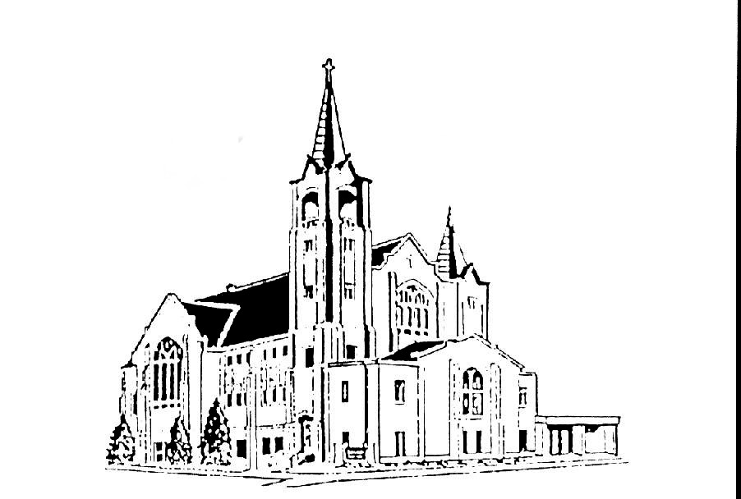 | Salem Lutheran Church  401 S. Lake St. Lake Mills IA 50450  Welcome to the House of the Lord  Second Sunday in Lent  March 12, 2022 – 5:30pm

OUR MISSION: We are God forgiven and mission driven.

OUR VISION: To be that Lake Mills place where belonging, healing, growing, serving and believing are open to all, regardless of background, experience or aptitude. Central to this is that we are a forgiving, mission-driven community, which means we all want to have an impact, shaped by the love of Christ to serve all others.

Saturday--5:30pm Worship Service  Preaching: Pastor Joel Guttormson  Organist: Ruth Sheldon  Reader: Ruth Sheldon  Liturgical Choir: Open  Sound: Brad Evenson  Acolytes: Open  Ushers: Opem  Communion Servers:  Altar Guild for March: Linda Helgeson, Gloria Kvale, Sharon Johnson | Sunday--9:00am Worship Service  Preaching: Pastor Joel Guttormson  Organist: Ruth Sheldon  Readers: Wayne VanVeldhuizen  Liturgical Choir: Nancy Guttormson, Larry Rice, Al Skellenger, Darlene Anderson  Sound: Al Skellenger  Live Stream: Brad Evenson  Acolytes: Lyle Thomson  Ushers: Lyle and Orloue Thomson  Communion Servers:  Altar Guild for March:  Linda Helgeson, Gloria Kvale, Sharon Johnson

The radio broadcast is given by an Anonymous Sponsor
who would like to say Thank You to those at Salem who
are so nice and helpful to others. You are appreciated!

Salem Contact Information:
Pastor Joel Guttormson: 641.596.0535  joelguttormson@gmail.com  Shannon Bruhns, Council President: 641.592.5978 / 641.590.1532  shelby@wctatel.net | Ruth Sheldon, Organist: 641.592.0184  Barb Kinseth, Custodian  Marci Adeogun, Office Admin: 641.590.1182  Salem Office: 641.592.1771  salem@wctatel.net
INTRODUCTION
Though we sometimes doubt and often resist God’s desire to protect and save us, our God persists. In holy baptism, God’s people have been called and gathered into a God-initiated relationship that will endure. Lent provides the church with a time and a tradition in which to seek God’s face again. Lent provides another occasion to behold the God of our salvation in the face of the Blessed One who “comes in the name of the Lord.”
GATHERING
PRELUDE
BELLS
ANNOUNCEMENTS

THANKSGIVING FOR THE WORD
Holy God,
our living Water, our faithful Companion, our true Guide,
by your Word you created a world with rivers and seas, wells and springs,
and in mercy you provided water for your people in the wilderness.
For your Word with the water of baptism, we thank you, O God.
We thank you, O God.

We praise you for Christ, who joined us in our desert,
calling us to righteousness, granting forgiveness,
and walking with us into newness of life.
For Jesus, your gracious Word, we glorify you, O God.
We glorify you, O God.

Through these days of Lent we plead for your Spirit,
that strengthened by your Word,
we may care for others and for the world you made,
and work for justice and peace for all.
For your Word in our hearts and minds, we praise you, O God.
We praise you, O God.

Receive our thanksgiving, and grant us your blessing,
Holy God, now and forever.
Amen.
GATHERING HYMN Eternal Lord of Love, Behold Your Church ELW #321
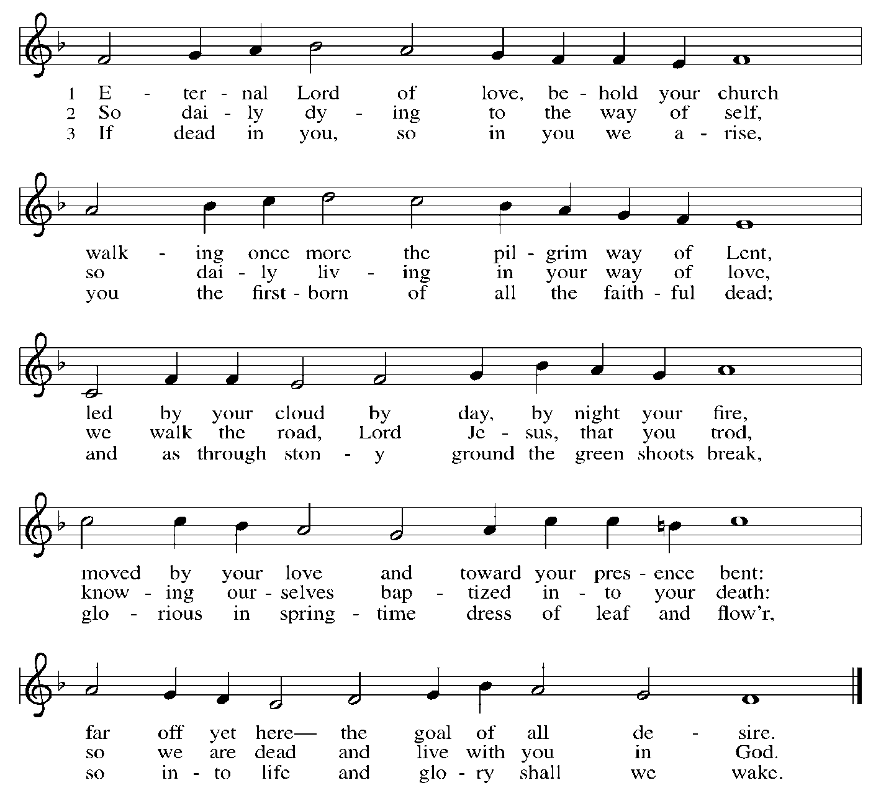

PRAYER OF THE DAY
God of the covenant, in the mystery of the cross you promise everlasting life to the world. Gather all peoples into your arms, and shelter us with your mercy, that we may rejoice in the life we share in your Son, Jesus Christ, our Savior and Lord, who lives and reigns with you and the Holy Spirit, one God, now and forever.
Amen.
WORD

FIRST READING Genesis 15:1-12; 17-18
¹After these things the word of the Lord came to Abram in a vision, “Do not be afraid, Abram, I am your shield; your reward shall be very great.” ²But Abram said, “O Lord God, what will you give me, for I continue childless, and the heir of my house is Eliezer of Damascus?” ³And Abram said, “You have given me no offspring, and so a slave born in my house is to be my heir.” ⁴But the word of the Lord came to him, “This man shall not be your heir; no one but your very own issue shall be your heir.” ⁵He brought him outside and said, “Look toward heaven and count the stars, if you are able to count them.” Then he said to him, “So shall your descendants be.” ⁶And he believed the Lord; and the Lord reckoned it to him as righteousness.
⁷Then he said to him, “I am the Lord who brought you from Ur of the Chaldeans, to give you this land to possess.” ⁸But he said, “O Lord God, how am I to know that I shall possess it?” ⁹He said to him, “Bring me a heifer three years old, a female goat three years old, a ram three years old, a turtledove, and a young pigeon.” ¹⁰He brought him all these and cut them in two, laying each half over against the other; but he did not cut the birds in two. ¹¹And when birds of prey came down on the carcasses, Abram drove them away.
¹²As the sun was going down, a deep sleep fell upon Abram, and a deep and terrifying darkness descended upon him.
¹⁷When the sun had gone down and it was dark, a smoking fire pot and a flaming torch passed between these pieces. ¹⁸On that day the Lord made a covenant with Abram, saying, “To your descendants I give this land, from the river of Egypt to the great river, the river Euphrates.”

Word of God. Word of life.
Thanks be to God.

SCRIPTURE SONG As the Dark Awaits the Dawn ELW #261
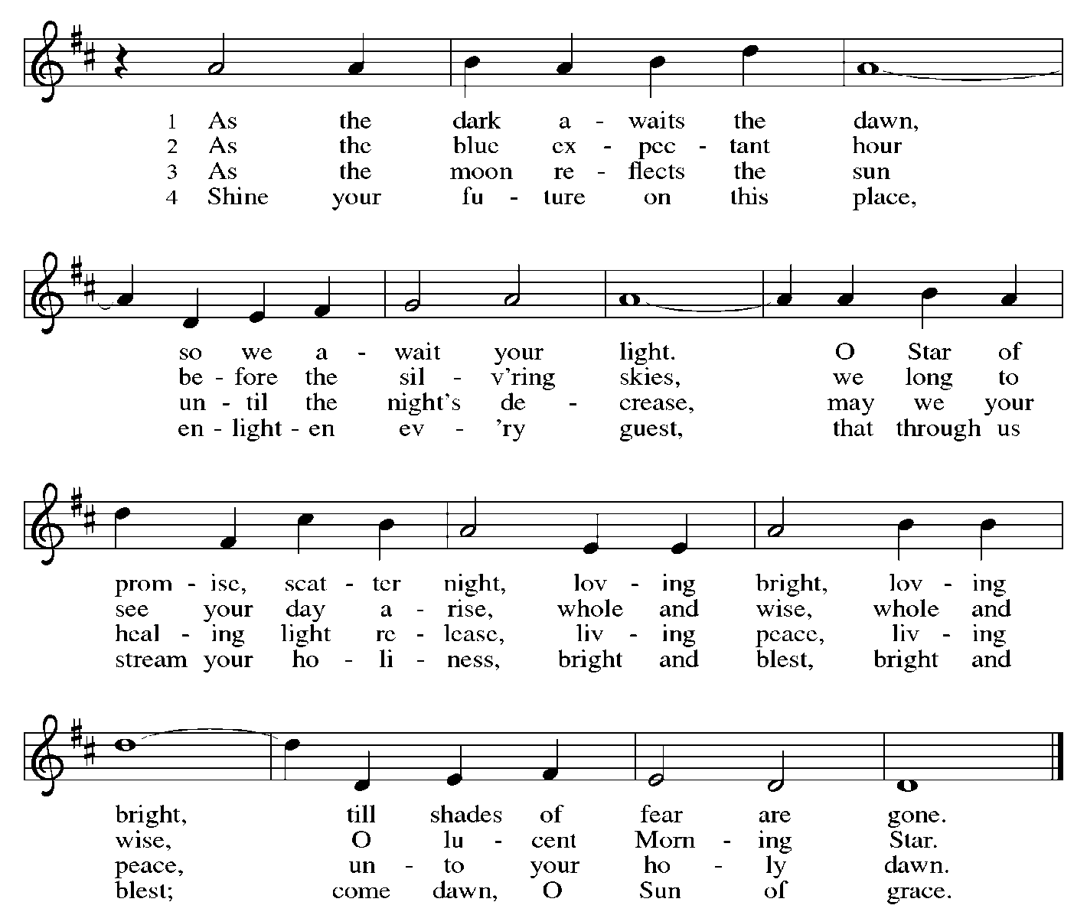

SECOND READING Philippians 3:17-4:1
¹⁷Brothers and sisters, join in imitating me, and observe those who live according to the example you have in us. ¹⁸For many live as enemies of the cross of Christ; I have often told you of them, and now I tell you even with tears. ¹⁹Their end is destruction; their god is the belly; and their glory is in their shame; their minds are set on earthly things. ²⁰But our citizenship is in heaven, and it is from there that we are expecting a Savior, the Lord Jesus Christ. ²¹He will transform the body of our humiliation that it may be conformed to the body of his glory, by the power that also enables him to make all things subject to himself. ^{4:1}Therefore, my brothers and sisters, whom I love and long for, my joy and crown, stand firm in the Lord in this way, my beloved.

Word of God. Word of life.
Thanks be to God.

GOSPEL ACCLAMATION Return to the Lord, Your God ELW p.142
We stand for the hearing of the gospel.
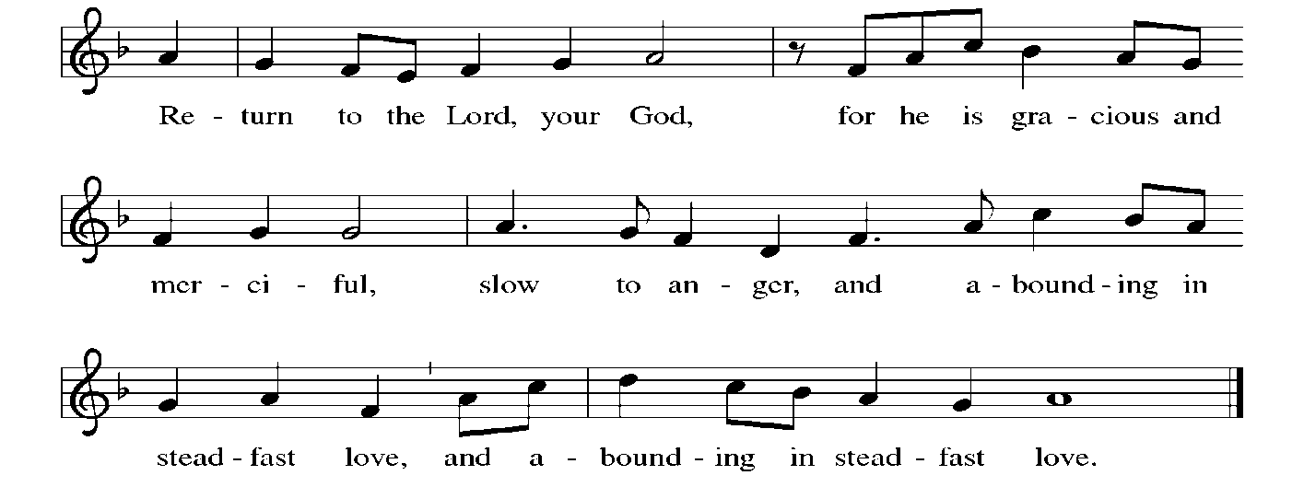

GOSPEL Luke 13:31-35
The Holy Gospel according to Luke
Glory to you, O Lord.
³¹At that very hour some Pharisees came and said to [Jesus,] “Get away from here, for Herod wants to kill you.” ³²He said to them, “Go and tell that fox for me, ‘Listen, I am casting out demons and performing cures today and tomorrow, and on the third day I finish my work. ³³Yet today, tomorrow, and the next day I must be on my way, because it is impossible for a prophet to be killed outside of Jerusalem.’ ³⁴Jerusalem, Jerusalem, the city that kills the prophets and stones those who are sent to it! How often have I desired to gather your children together as a hen gathers her brood under her wings, and you were not willing! ³⁵See, your house is left to you. And I tell you, you will not see me until the time comes when you say, ‘Blessed is the one who comes in the name of the Lord.’ ”

The Gospel of our Lord.
Praise to you, O Christ
SERMON

HYMN OF THE DAY Mothering God, You Gave Me Birth ELW #735
We stand for the hymn of the day.
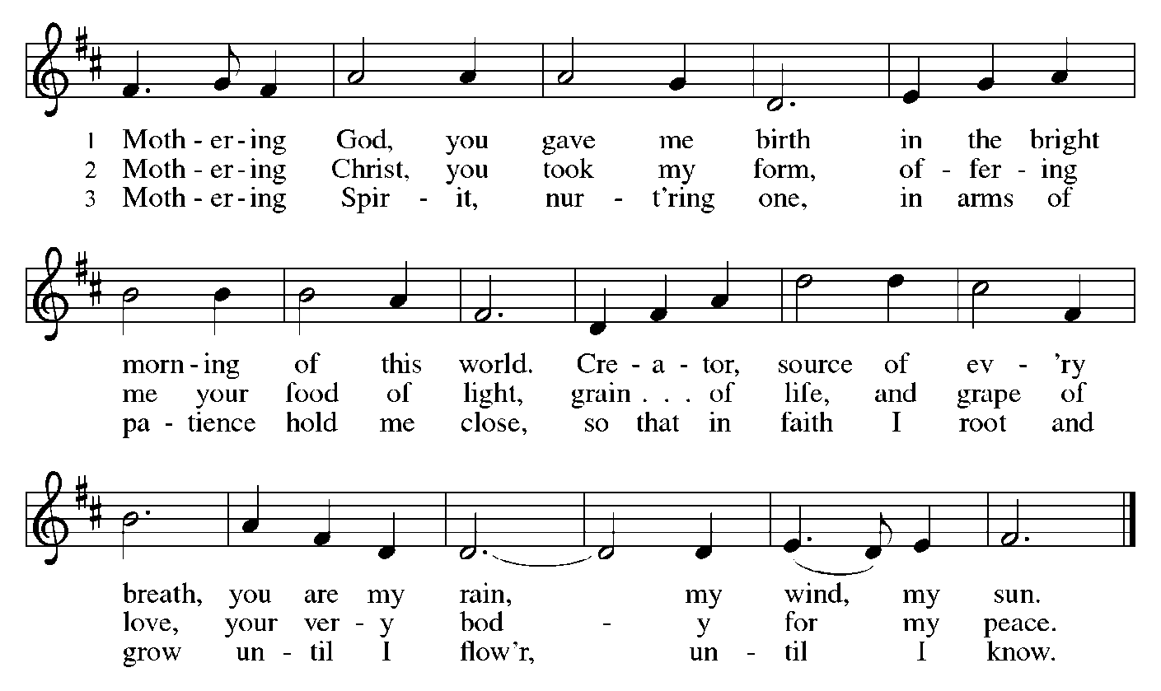

RESPONSE TO THE WORD

AFFIRMATION OF FAITH Apostles’ Creed
I believe in God, the Father almighty, creator of heaven and earth.
I believe in Jesus Christ, God’s only Son, our Lord,
who was conceived by the Holy Spirit, born of the virgin Mary, suffered under Pontius Pilate, was crucified, died, and was buried; he descended to the dead. On the third day he rose again; he ascended into heaven, he is seated at the right hand of the Father, and he will come to judge the living and the dead.
I believe in the Holy Spirit, the holy catholic church, the communion of saints, the forgiveness of sins, the resurrection of the body, and the life everlasting.
Amen.
PRAYERS
We will be seated for the prayers
Drawn close to the heart of God, we offer these prayers for the church, the world, and all who are in need.
A brief silence.

You gather the church into a community of mercy and grace. Unify Christians around the globe in efforts to proclaim good news even in the face of opposition and to protect those whose lives are imperiled by the gospel. Merciful God,
receive our prayer.

You create the entire universe and call it good. Hinder those who would cause further destruction to our planet’s fragile ecosystems, and augment the calls of those who advocate for thoughtful stewardship of the earth’s resources. Merciful God,
receive our prayer.

You raise up leaders committed to love and justice. Nurture in those who govern patience to receive criticism, openness to new ideas, and courage to change course when needed for the sake of the common good. Merciful God,
receive our prayer.

You hear us when we cry to you. Attend to those expecting a child, and console those who have experienced miscarriage. Comfort veterans enduring post-traumatic stress. Shield those endangered by domestic violence. Uphold those who are ill or grieving (especially). Merciful God,
receive our prayer.

You kindle faith that moves us into action. Guide children and adults preparing for baptism or confirmation. Empower Sunday school teachers, confirmation leaders, and parents who share their faith with younger generations. Give us all a renewed sense of vocation. Merciful God,
receive our prayer.

You welcome us into your heavenly realm. We give thanks for those whose labors on earth are ended and who now rest with you. On the final day, gather all of us, with them, in your loving arms. Merciful God,
receive our prayer.
Pastor concludes the prayers
Accept the prayers we bring, O God, on behalf of a world in need, for the sake of Jesus Christ.
Amen.

PEACE
The peace of Christ be with you all.
And also with you.

RESPONSE TO THE WORD

OFFERING
The offering is being collected at the beginning of the service as you walk in. The usher will bring the offering forward for the mission of the church, including the care of those in need at the time of the offering song and prayer.

MUSICAL OFFERING

OFFERING PRAYER
Extravagant God,
you have blessed us with the fullness of creation. Now we gather at your feast
where you offer us the food that satisfies. Take and use what we offer here, come among us, and feed us with the body and blood of Christ, in whose name we pray.
Amen.

THE LORD’S PRAYER
Our Father, who art in heaven, hallowed be thy name, thy kingdom come, thy will be done, on earth as it is in heaven. Give us this day our daily bread; and forgive us our trespasses, as we forgive those who trespass against us; and lead us not into temptation, but deliver us from evil. For thine is the kingdom, and the power, and the glory, forever and ever.
Amen

SENDING

Blessing
You are children of God, anointed with the oil of gladness
and strengthened for the journey.
Almighty God, motherly, majestic, and mighty, ☩ bless you this day and always.
Amen.

SENDING HYMN O God in Heaven ELW #748
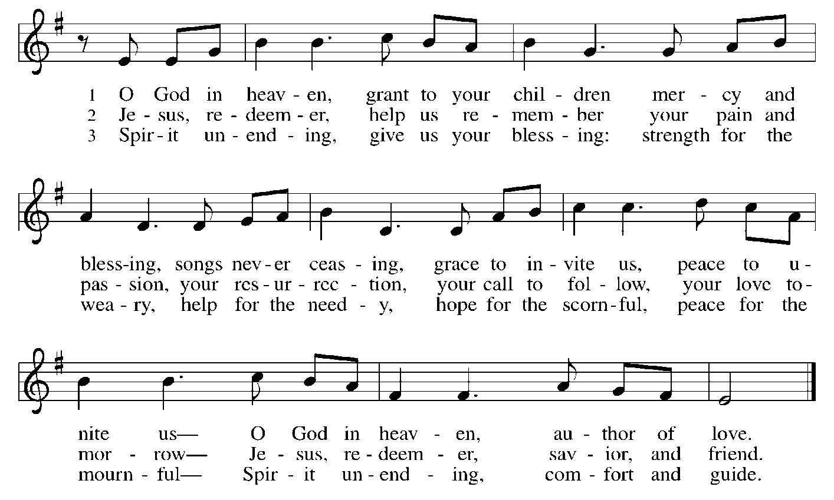

Dismissal
Go in peace. Jesus meets you on the way.
Thanks be to God.

POSTLUDE

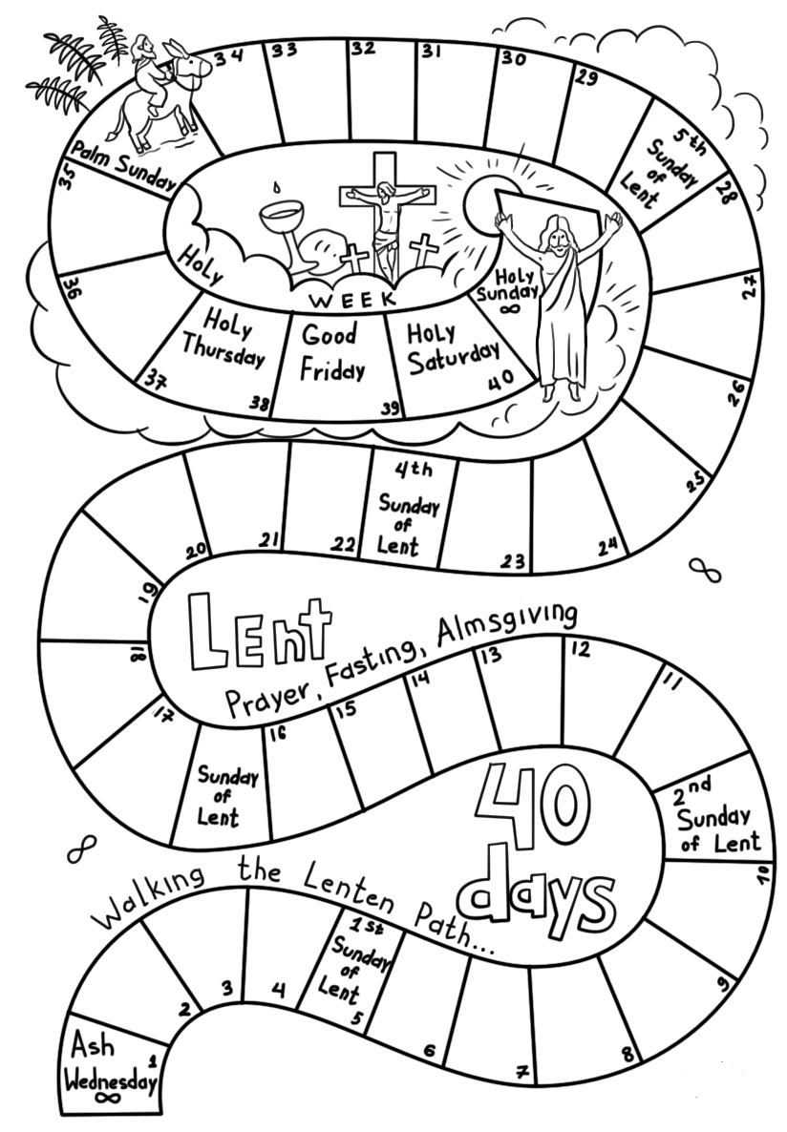

From sundaysandseasons.com.
Copyright © 2021 Augsburg Fortress. All rights reserved. Reprinted by permission under Augsburg Fortress Liturgies Annual License #SAS020622.
New Revised Standard Version Bible, Copyright © 1989, Division of Christian Education of the National Council of the Churches of Christ in the United States of America. Used by permission. All rights reserved.
Revised Common Lectionary, Copyright © 1992 Consultation on Common Texts, admin Augsburg Fortress. Used by permission.

